What is a Computer Network?

Using a computer connected to a network allows us to…

Type of backup | Describe the role of each component in a network?
Server:

Router:

Hub:
Switch:
Bridge:

What are the differences between Bluetooth and Wifi?
Bluetooth | Wifi

What is the purpose of a Firewall?

What is the purpose of a Proxy Server?

What are the differences between the internet and Intranet?
Internet | Intranet

What is data Encryption?

Describe Three methods of authentication (Network Security)?
1)

2)

3)

Provide a brief description of the following types of Networks?
LAN | WAN | WLAN

Use examples to describe the difference between a weak password and a strong password
Describe how data is sent from a networked computer to a computer on a different network.
Describe two similarities between physical faxing and electronic faxing.
Describe three differences between physical faxing and electronic faxing.
Describe four items which can be provided by an ISP.

Give three reasons why some companies have intranets.
Explain, using examples, what is meant by authentication techniques.
Describe the differences in use between WiFi and Bluetooth.
In order to make reliable information available to all students, schools often put the information on their intranet. Describe what is meant by an intranet.
Most data protection acts include the principle that data should be stored securely. List four other principles of a typical data protection act.
Fiona wants to communicate with her friend Myfanwy using her mobile phone.
Describe four ways she could do this.
Describe the details of computer addresses that are stored by a router.
Internet banking can be used by bank customers to check their account balance.
Many ways of logging into such a system involve the use of passwords.

Describe three methods of minimising the possibility of passwords being misused if intercepted.
Juanita has a computer and a contract with an ISP. When she searches the internet she does not find relevant information quickly.

Describe three ways she could reduce the amount of excess information she gets without changing either her computer or ISP.
Discuss the effectiveness of different methods which could be used to prevent unauthorised access to a laptop computer.
Tick whether the following statements would most appropriately apply to the internet or an intranet.

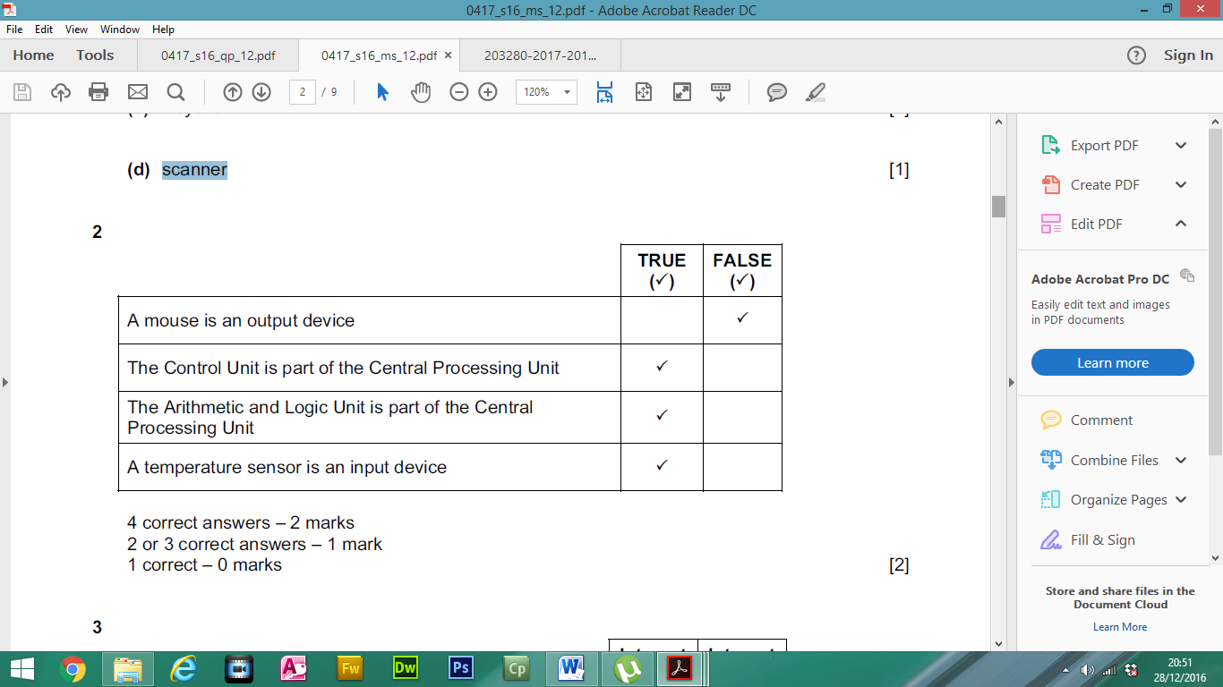
A piece of programming code which maliciously deletes files is called
_________________
The scrambling of data to make it unreadable by unauthorised users is called
_________________

A school’s Science department has a network which uses WiFi. A teacher has a laptop computer and whilst in school wishes to connect to this network.

Write down the name of this type of network.
_________________
In order to access the network the laptop must be within range of a type of WiFi network device.

Write down the name of this type of device.
_________________

Describe how this device is connected to the network using an ethernet cable.
_________________

WiFi networks can be limited in their range.
Describe one other disadvantage of a WiFi network compared to a cabled network.
Explain what is meant by VOIP.
Name two items of computer hardware that are needed in order to make a VOIP phone call from one computer to another.
Tick whether the following are features of emails or traditional faxes.
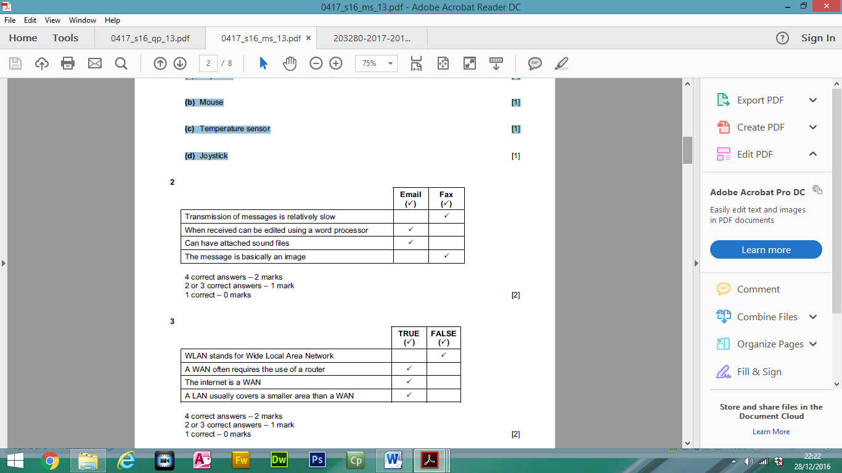
Tick whether the following statements are true or false.
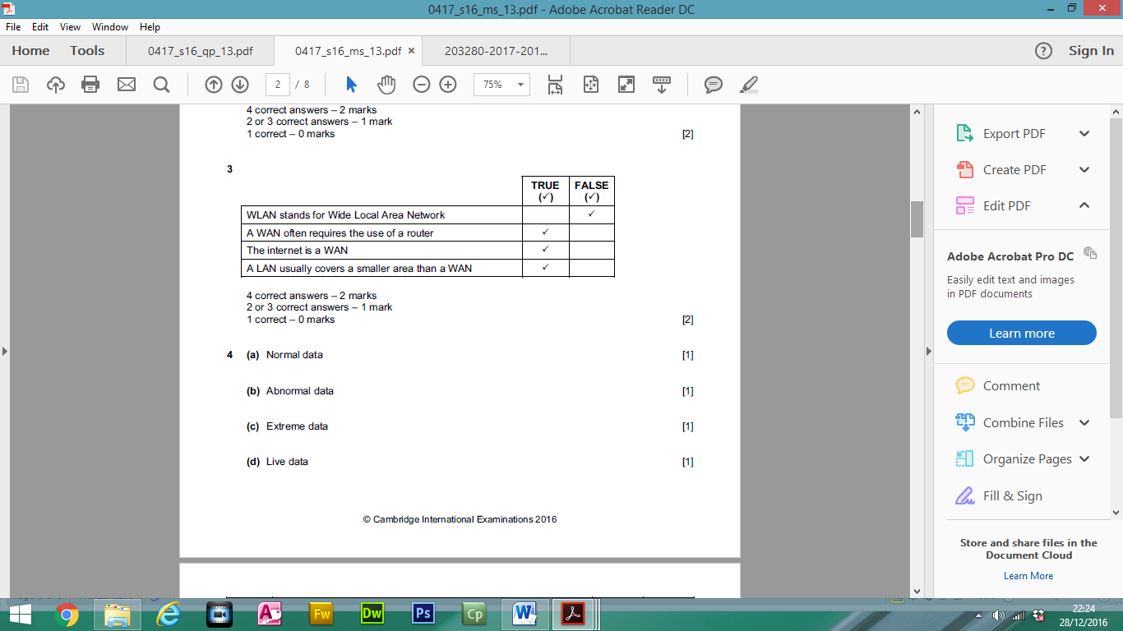

Describe what an ISP is and, apart from security measures, describe what it offers its customers.

